**VISVESVARAYA TECHNOLOGICAL UNIVERSITY**

**“JnanaSangama”, Belgaum -590014, Karnataka.**



**PROJECT WORK-1 REPORT**

**on**

**EVENT ORGANISATION SYSTEM**

***Submitted by***

**S SKANDA(1BM19CS137)**

**S K BALAJI(1BM19CS134)**

**SAQUIB NAUSHAD(1BM19CS144)**

**SAIPRAVEEN MARNI (1BM19CS138)**

***Under the Guidance of***

|  |  |
| --- | --- |
| **Prof. Lohit J J**  **Assistant Professor, BMSCE** |  |

***in partial fulfillment for the award of the degree of***

**BACHELOR OF ENGINEERING**

***in***

**COMPUTER SCIENCE AND ENGINEERING**



**B.M.S. COLLEGE OF ENGINEERING**

**(Autonomous Institution under VTU)**

**BENGALURU-560019**

**Sep-2020 to Jan-2021**

**B. M. S. College of Engineering,**

**Bull Temple Road, Bangalore 560019**

(Affiliated To Visvesvaraya Technological University, Belgaum)

**Department of Computer Science and Engineering**



**CERTIFICATE**

This is to certify that the project work entitled “**EVENT ORGANISATION SYSTEM**” carried out by

**S K BALAJI(1BM19CS134), S.SKANDA (1BM19CS137), SAIPRAVEEN MARNI(1BM19CS138), AND SAQUIB NAUSHAD(1BM19CS144)** who are bonafide students of **B. M. S. College of Engineering.** It is in partial fulfillment for the award of **Bachelor of Engineering in Computer Science and Engineering** of the Visveswaraiah Technological University, Belgaum during the year 2020-2021. The project report has been approved as it satisfies the academic requirements in respect of **Project Work-1 (19CS3PWPW1)**work prescribed for the said degree.

Signature of the Guide                 Signature of the HOD

Prof. Lohit J J Dr. Umadevi V

Professor Associate Prof.& Head, Dept. of CSE

BMSCE, Bengaluru BMSCE, Bengaluru

External Viva

Name of the Examiner                                                                                       Signature with date

1._____________________________ ________________________

2. _____________________________ _________________________

**B.M.S. COLLEGE OF ENGINEERING**

**DEPARTMENT OF COMPUTER SCIENCE AND ENGINEERING**



***DECLARATION***

We, **S.K.BALAJI(1BM19CS134), S.SKANDA(1BM19CS137), SAIPRAVEEN MARNI(1BM19CS138), SAQUIB NAUSHAD(1BM19CS144)**, students of 3rd Semester, B.E, Department of Computer Science and Engineering, B. M. S. College of Engineering, Bangalore, hereby declares that this Project Work-1entitled "EVENT ORGANISATION SYSTEM" has been carried out by us under the guidance of Prof. Lohit J J, Professor, Department of CSE, B. M. S. College of Engineering, Bangalore during the academic semester Sep-2020-Jan-2021

We also declare that to the best of our knowledge and belief, the development reported here is not from part of any other report by any other student.

Signature

S.K.BALAJI (1BM19CS134)

S SKANDA(1BM19CS137)

SAIPRAVEEN MARNI (1BM19CS138)

SAQUIB NAUSHAD(1BM19CS144)

**Phase 1**

**INTRODUCTION**

**1.ABOUT THE PROJECT**

As we all know the student life of every person is very eventful. We participate in many events such as blood donation camps, hackathons, tree plantations, cultural events, and many more. But many of the students lack awareness of the happening of the events or do not get the registration forms on time. Thus sometimes the organizers complain about the low number of participants.

As an effort to solve this problem we have come up with an idea of an event organization website for colleges.

**2. ABOUT THE WEBSITE**

This website supports two types of users:

**a.Host:** for people who would like to host events and ask students for volunteering and participation.

**b. Student:** for people who are eager to learn and participate in events.

**Functionalities under Student login**

i. Can register for Events (like campaigns, webinar) through the online application form

ii. Displaying the list of Events registered

**Functionalities under Host login**

i. Creating an event

ii. Specify requirements for registration

iii. View additional information about their events (hosted in the past)

Additionally, there is a separate page for events where one can view upcoming events and get the registration forms for them.

## 

## **3. Design Layouts: Handwritten Screenshots of Webpages**

### **3.1: Homepage / Landing page**

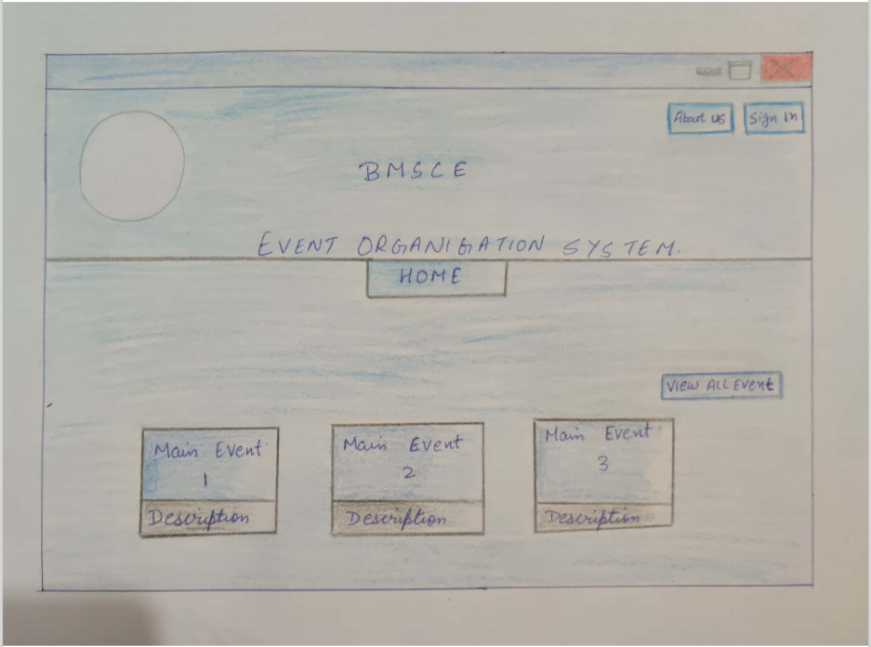

**3.2 Create account / Sign Up page**

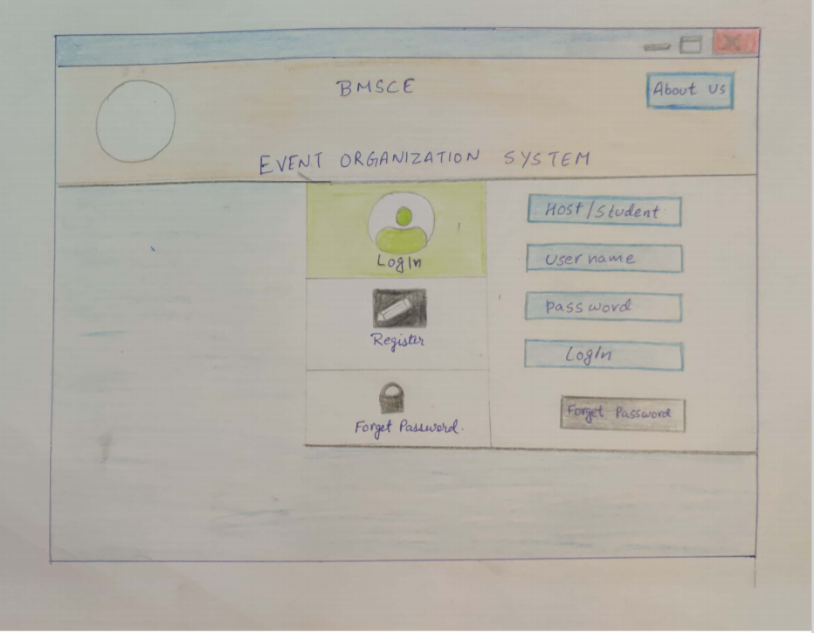

### **3.3: Host Login Page**

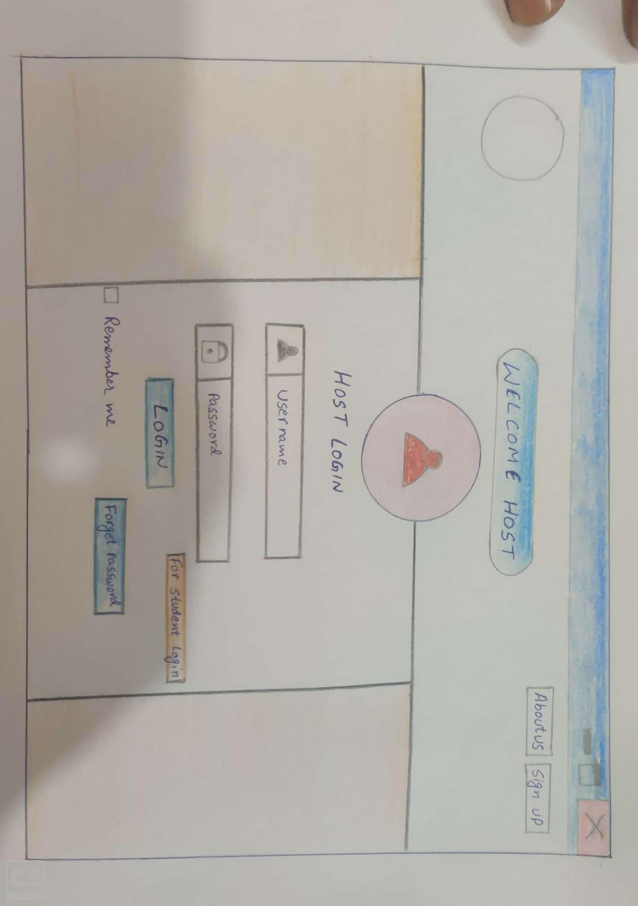

### **3.4: Host Dashboard**

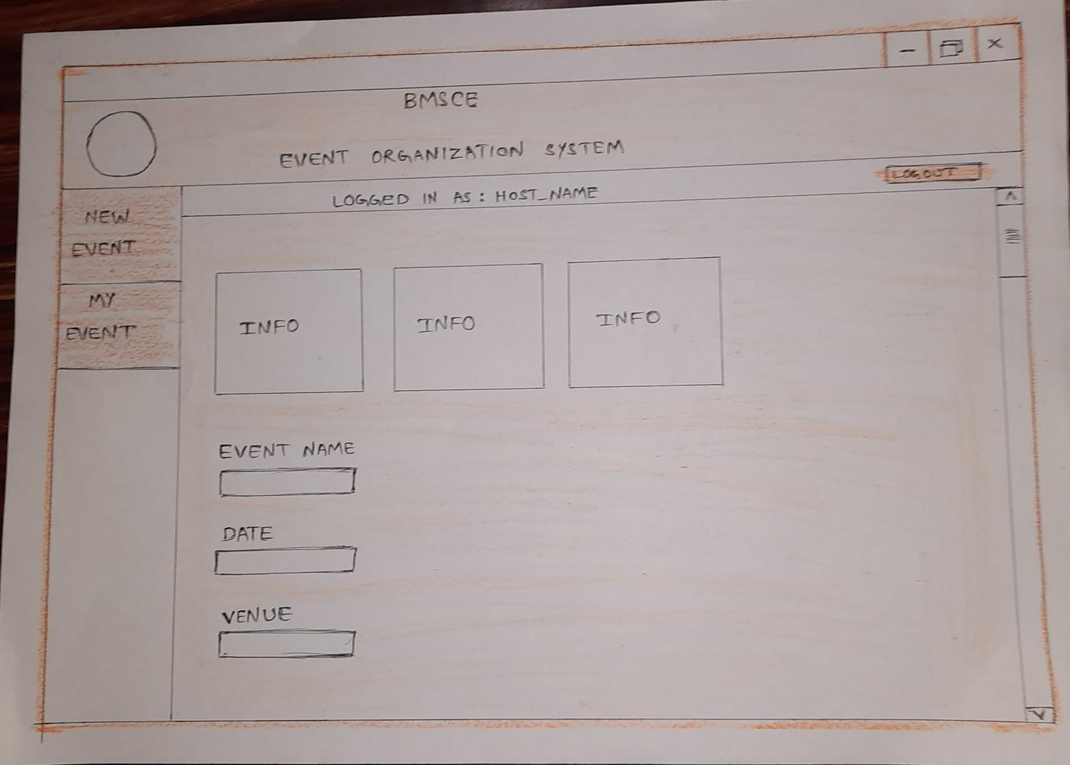

### **3.5: Student Login Page.**

**3.6 Student Dashboard**

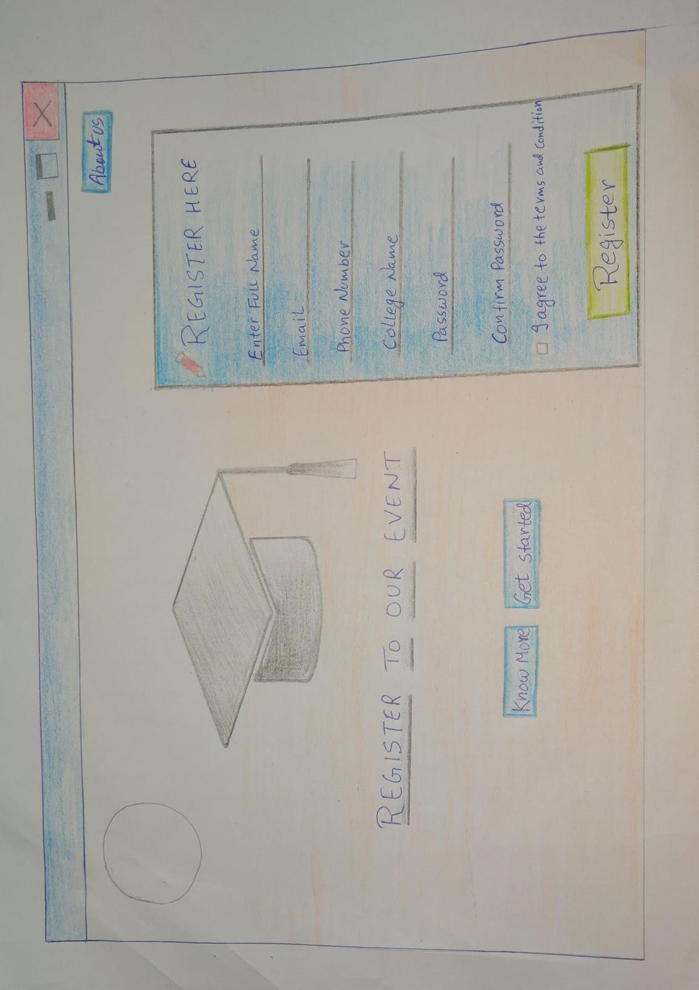

### **3.7: A Page To DIsplay ALL EVENTS**

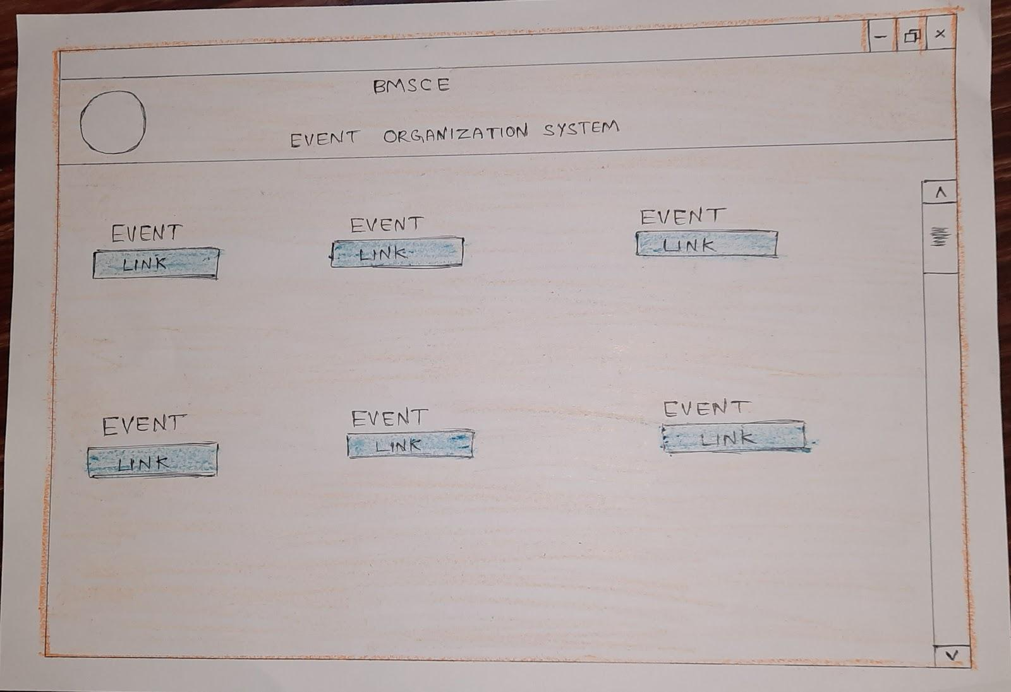

### **3.8: About Us and Contact page**

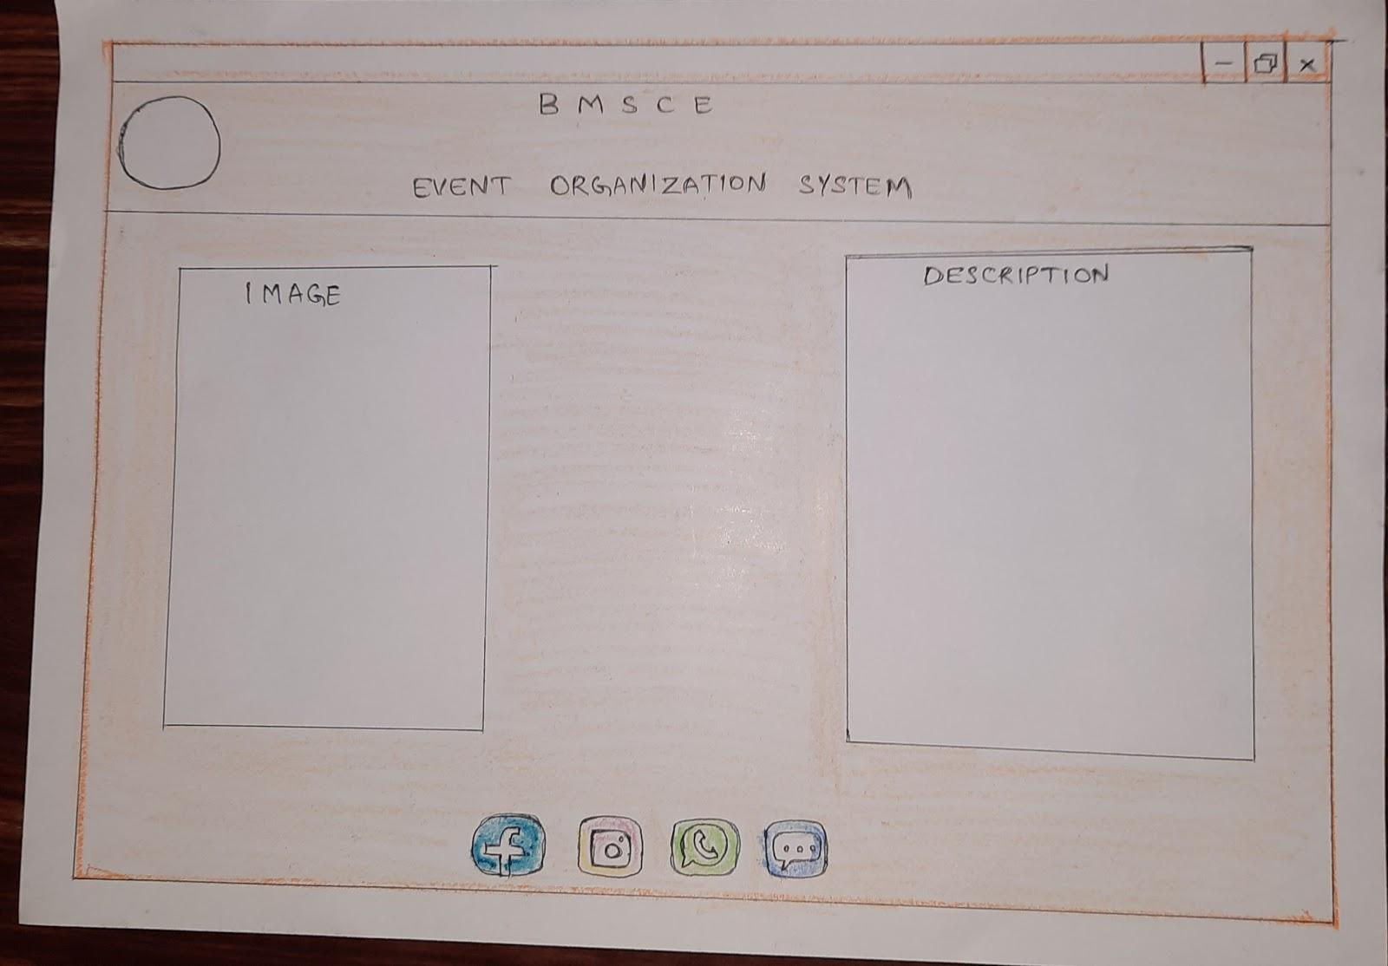

**Phase 2 & 3**

**3. Design Layouts: ScreenShots of Webpages**

**3.1 Homepage/Landing page**

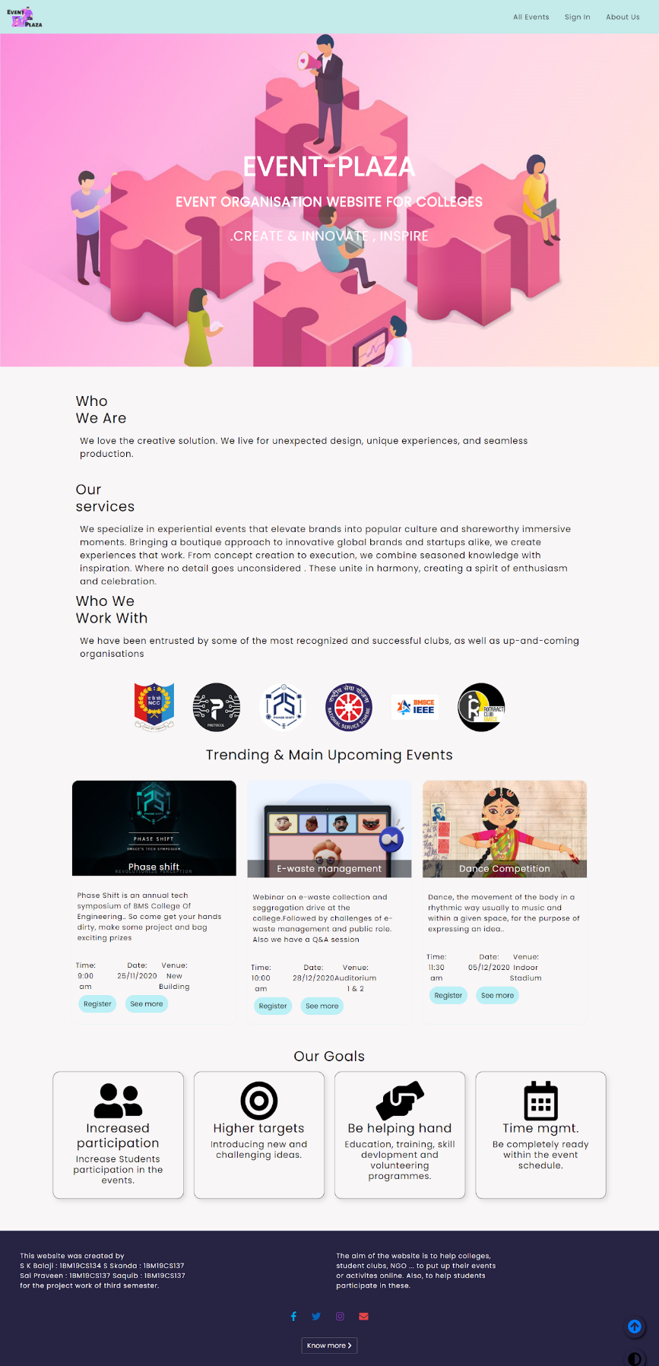

**3.2 Create account / Sign Up page**

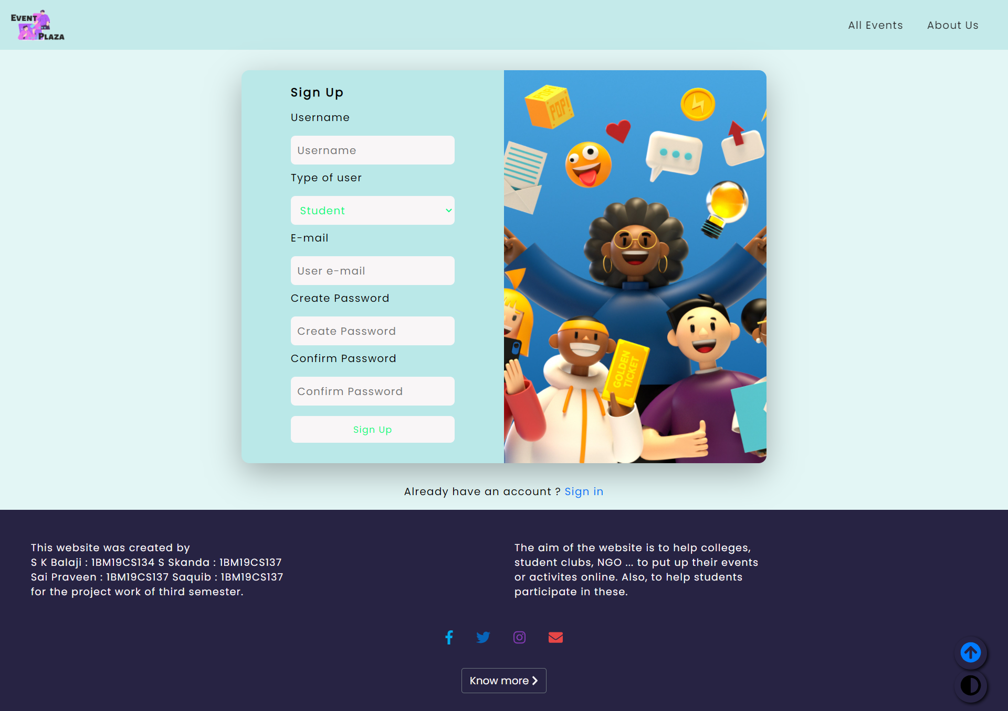

### **3.3: Host Login Page**

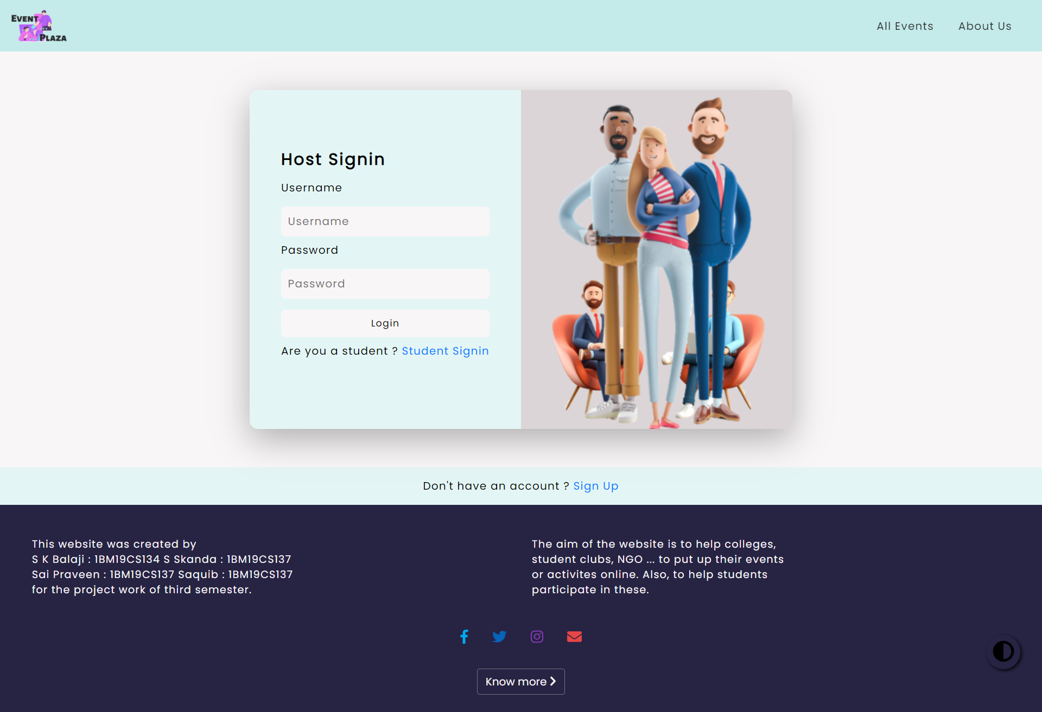

### **3.4 HOST DASHBOARD**

### **3.5: Student Login Page.**

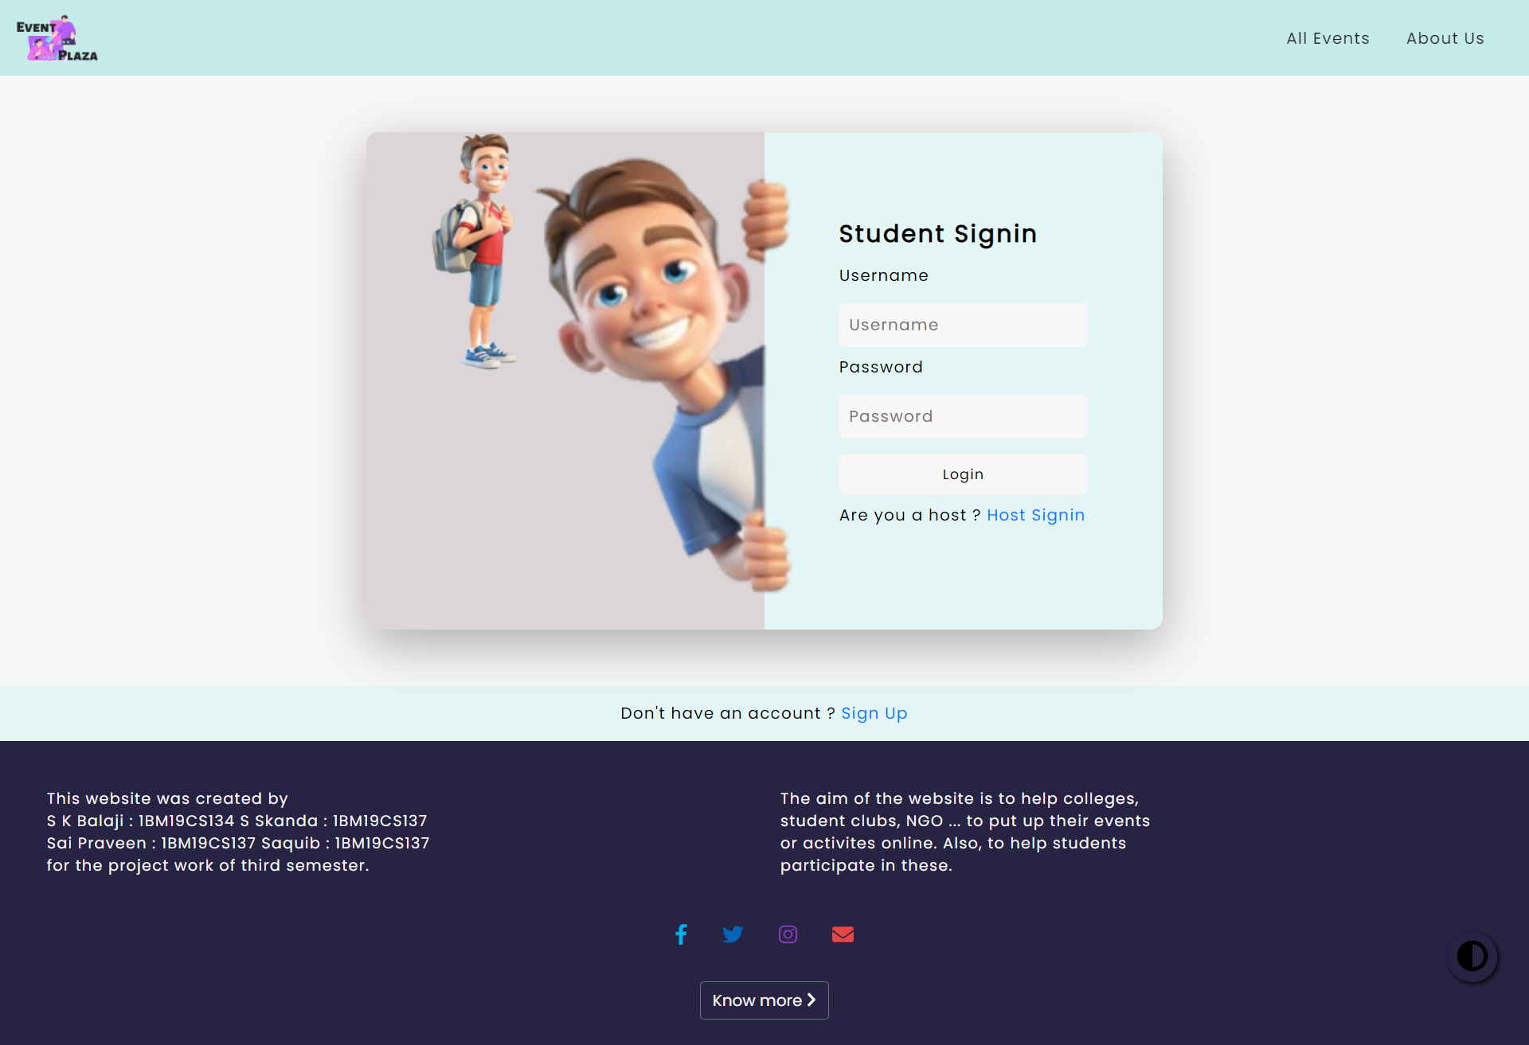

### **3.6 Student Dashboard**

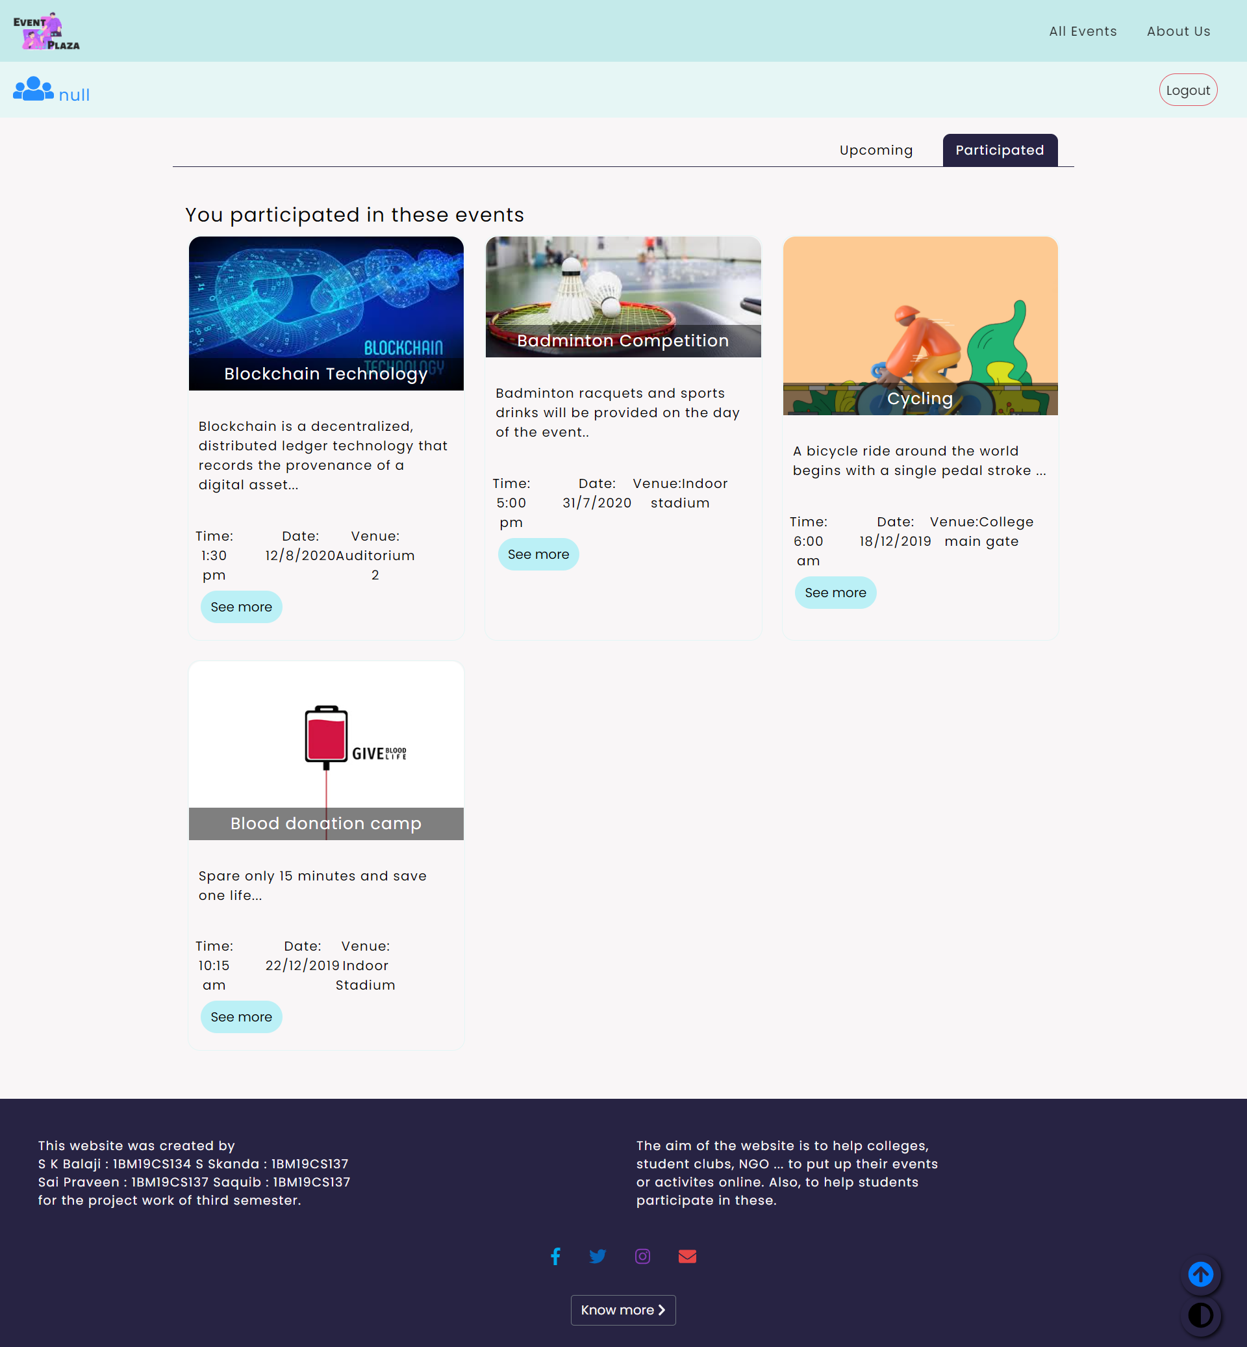

### **3.7: A Page To Display ALL EVENTS**

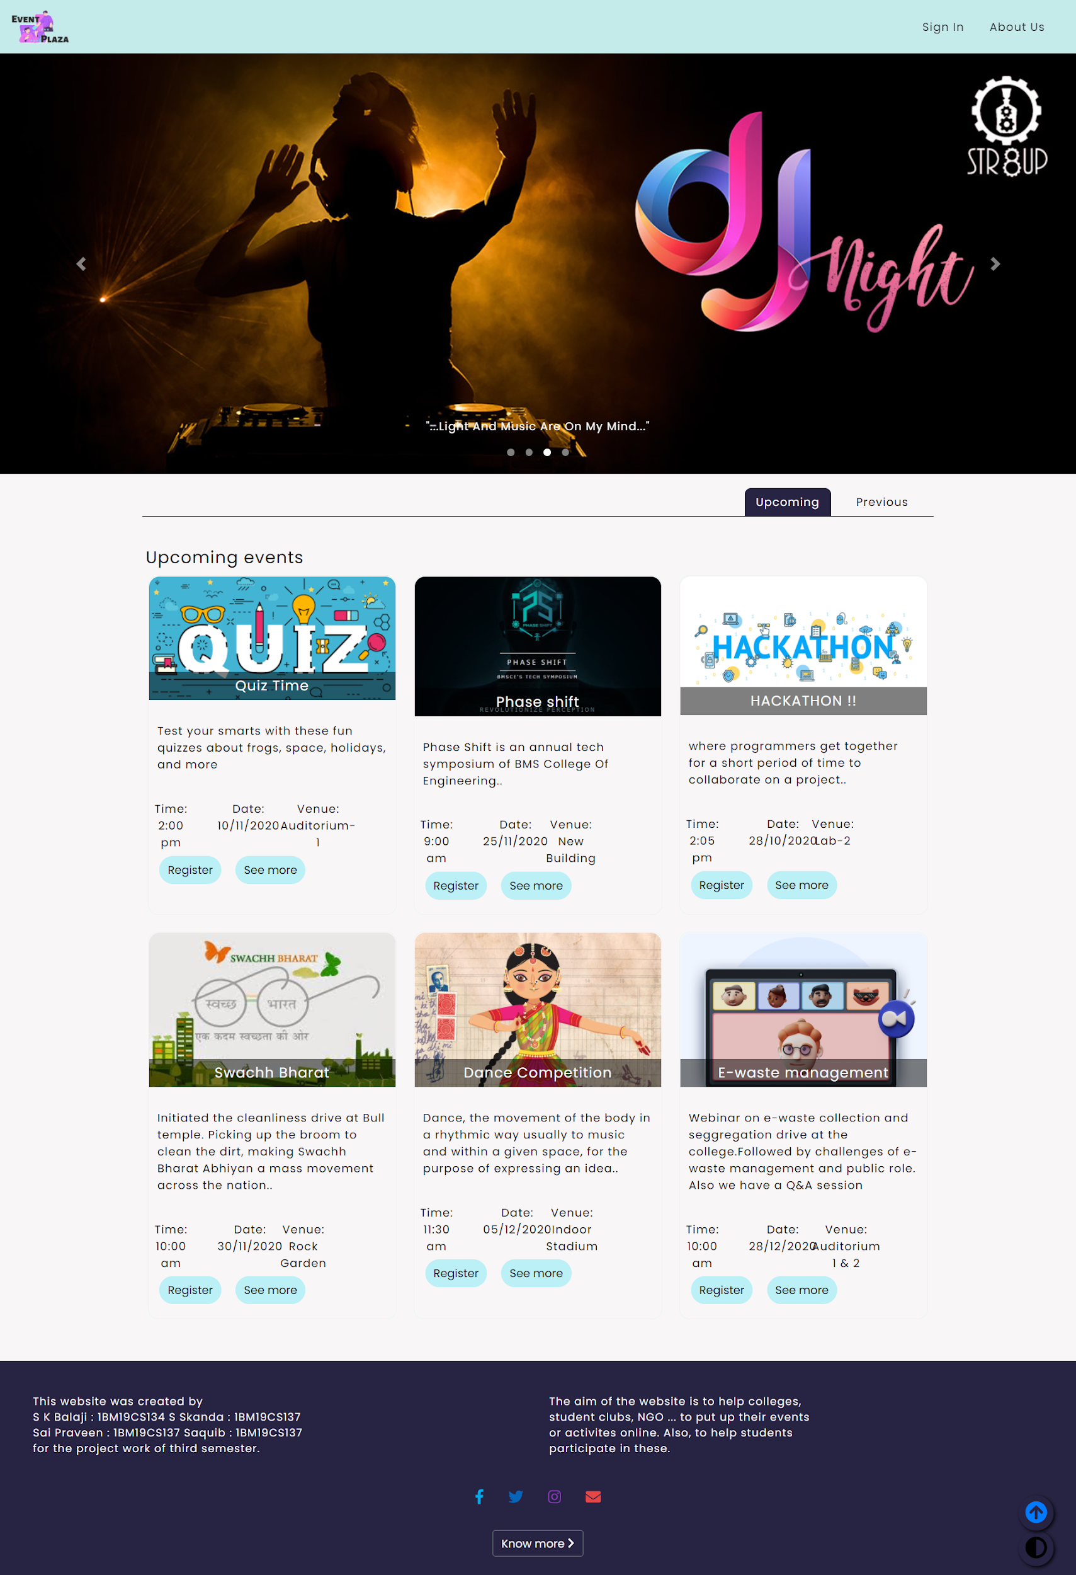

### **3.8: About Us and Contact page**

### 

**Pahse 3**

**Added animation to home page**

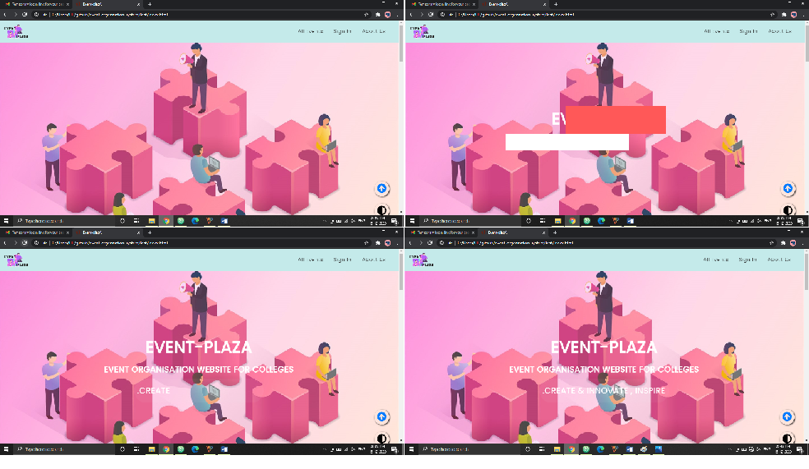

**Added back to top button**

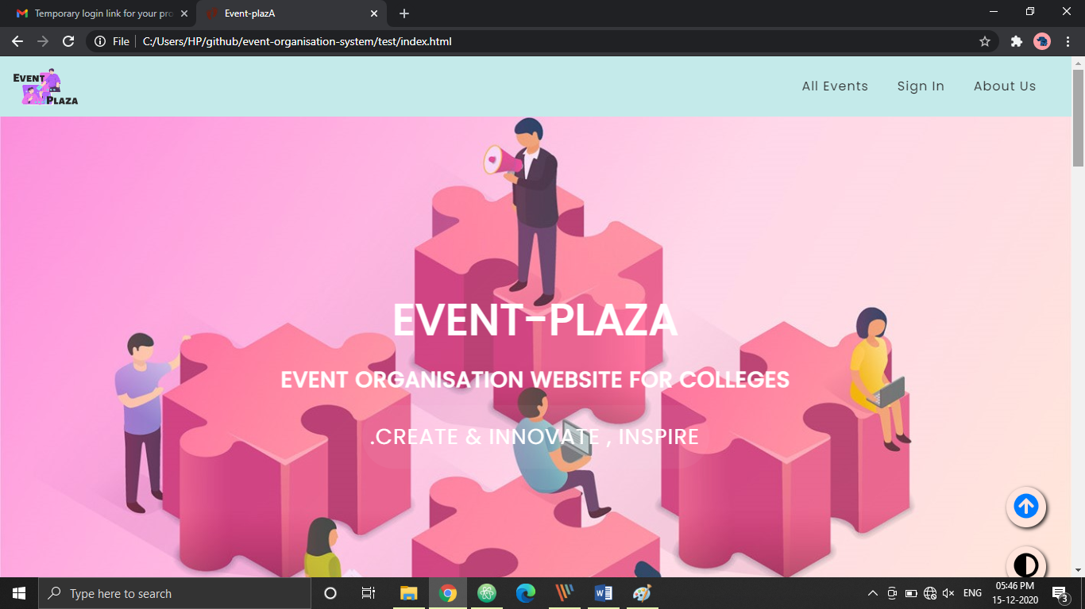helps the user to navigate to top of the page from any position

**Added the much popular dark mode to the website**

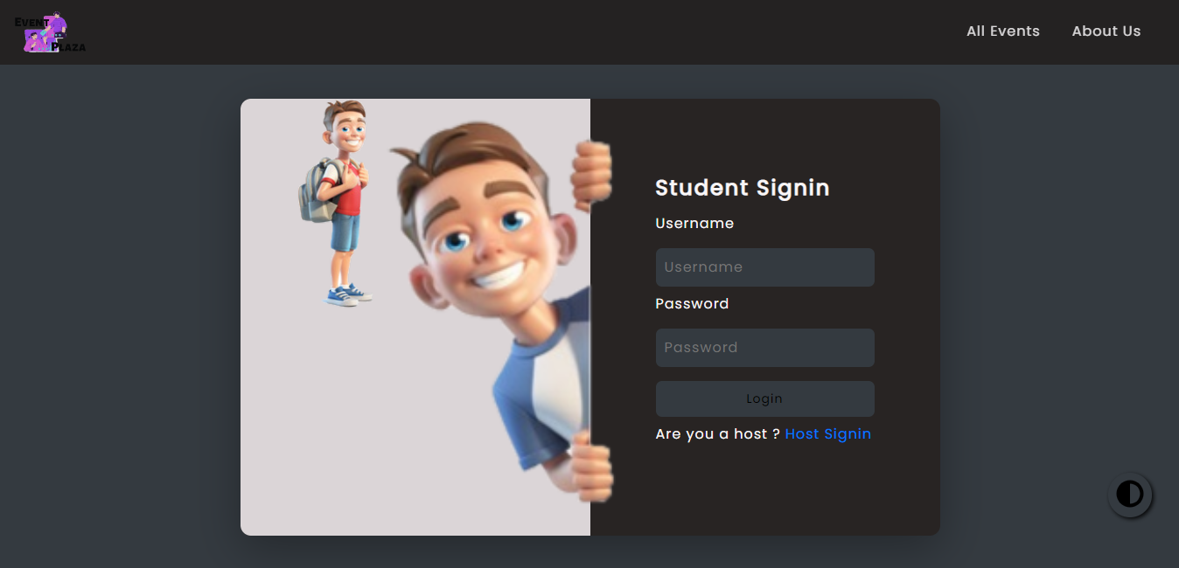

 this button helps the user to toggle the theme of the website

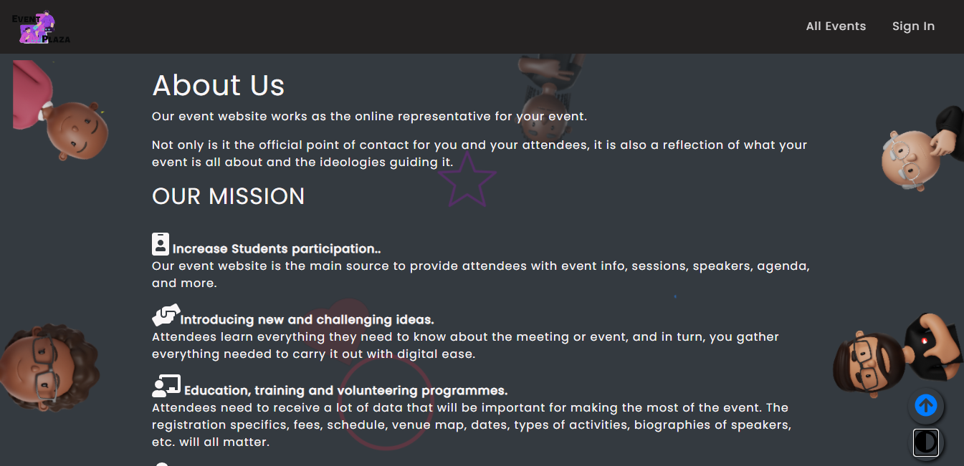

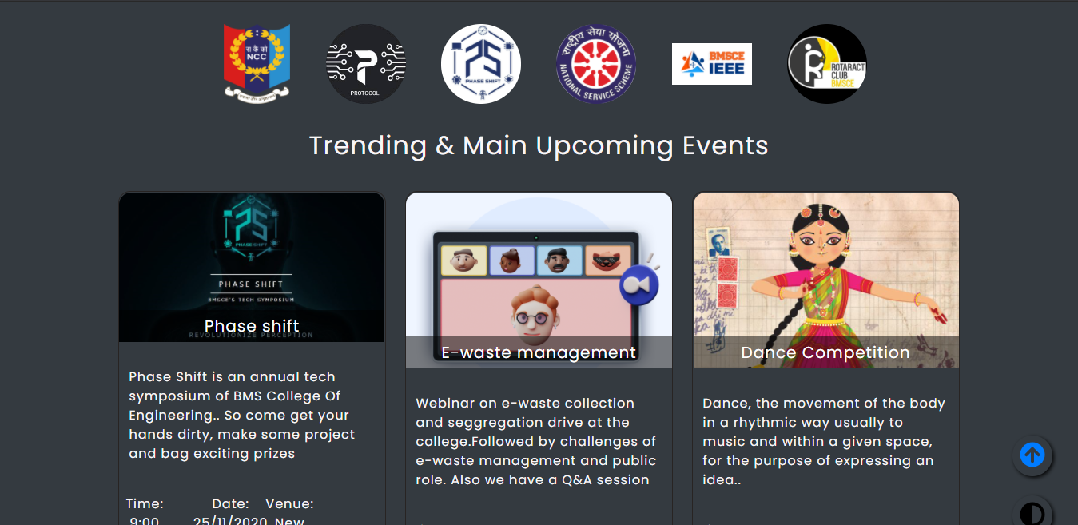

**Added the registration links**

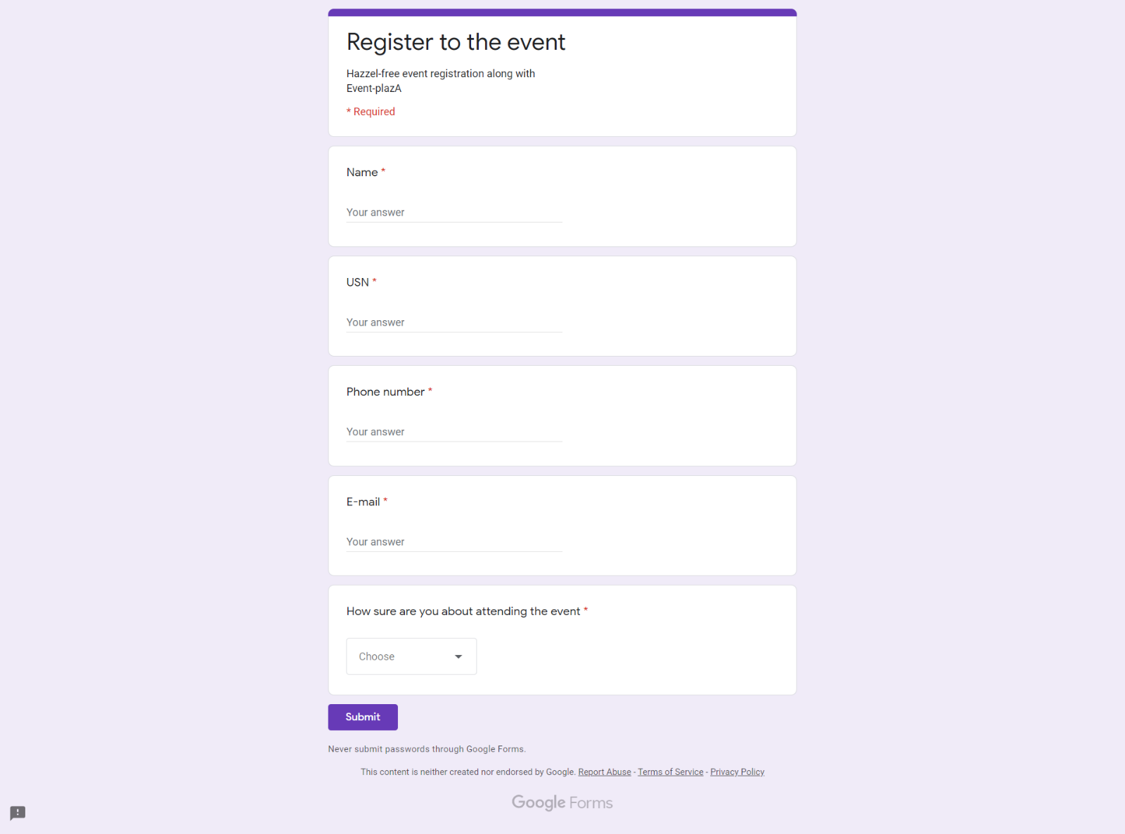

**Added modals to show the information about events**

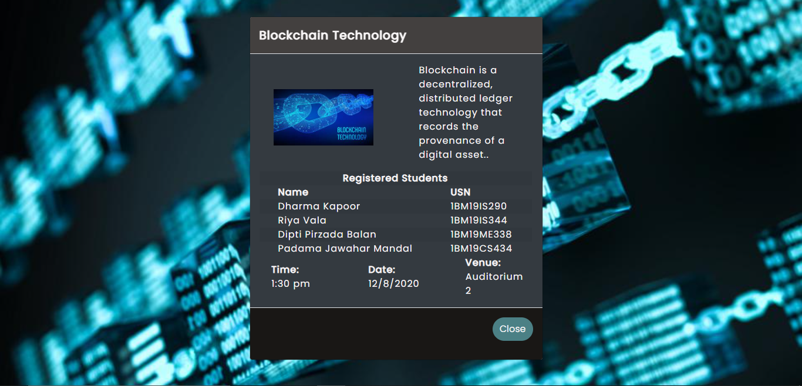

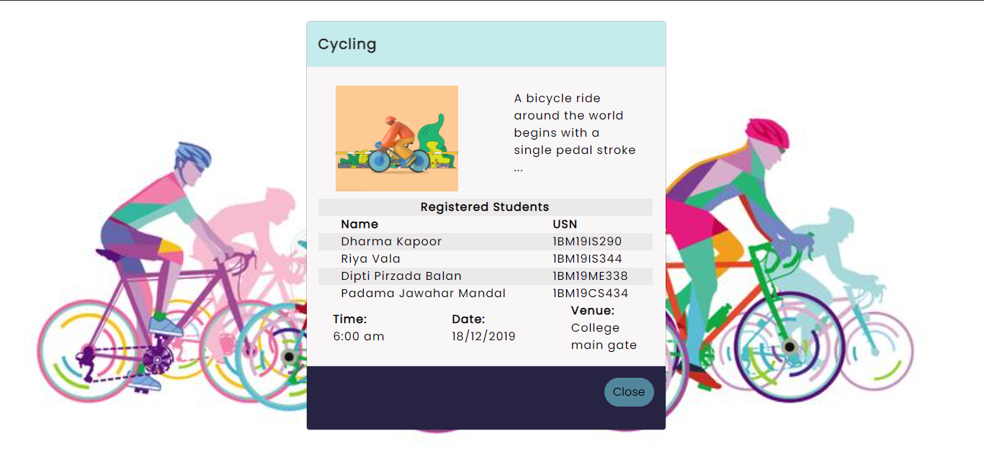

**Added validations to the forms**

1)Incorrect username / password

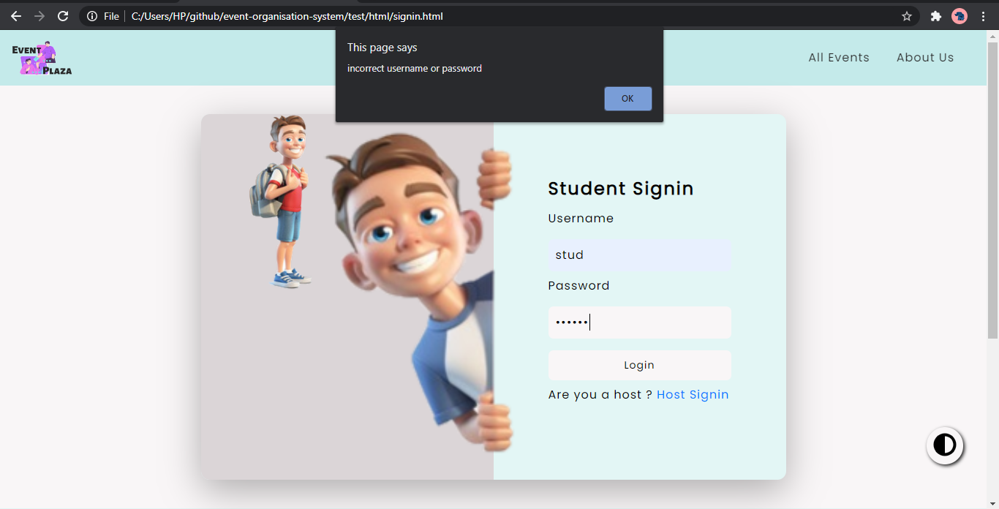

2)Match the password length and other required parameters

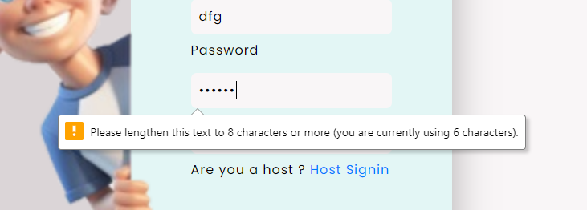

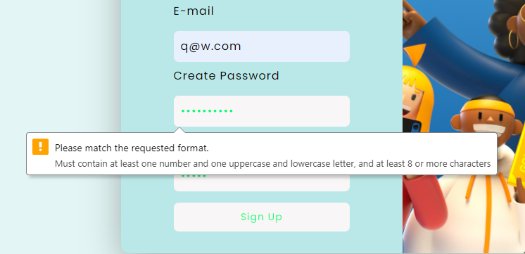

3) some fields are made compulsory

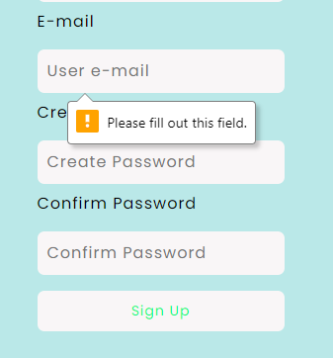

4)Passwords are matched before signup

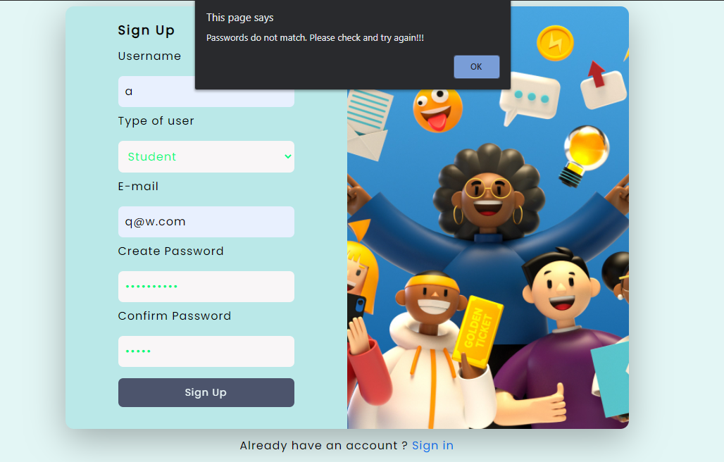

**Made the site responsive by adding media query breakpoints and CSS properties**

1. Navbar collapses on small screens

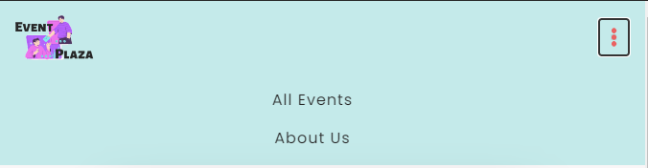

2)Image disappears on shrinking screen size in login and signup page

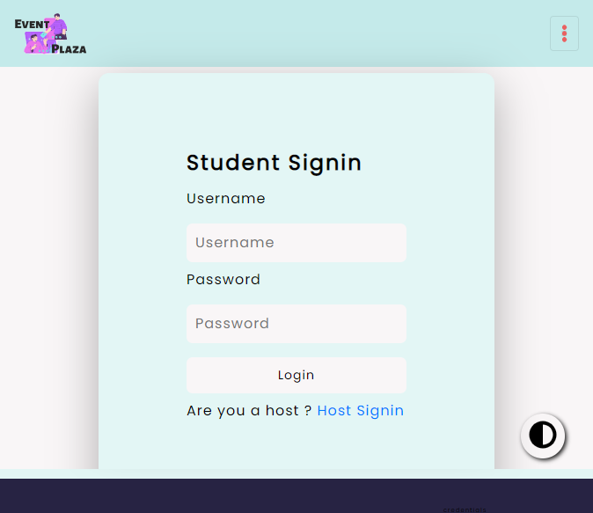

3)event card occupies full-screen in small devices

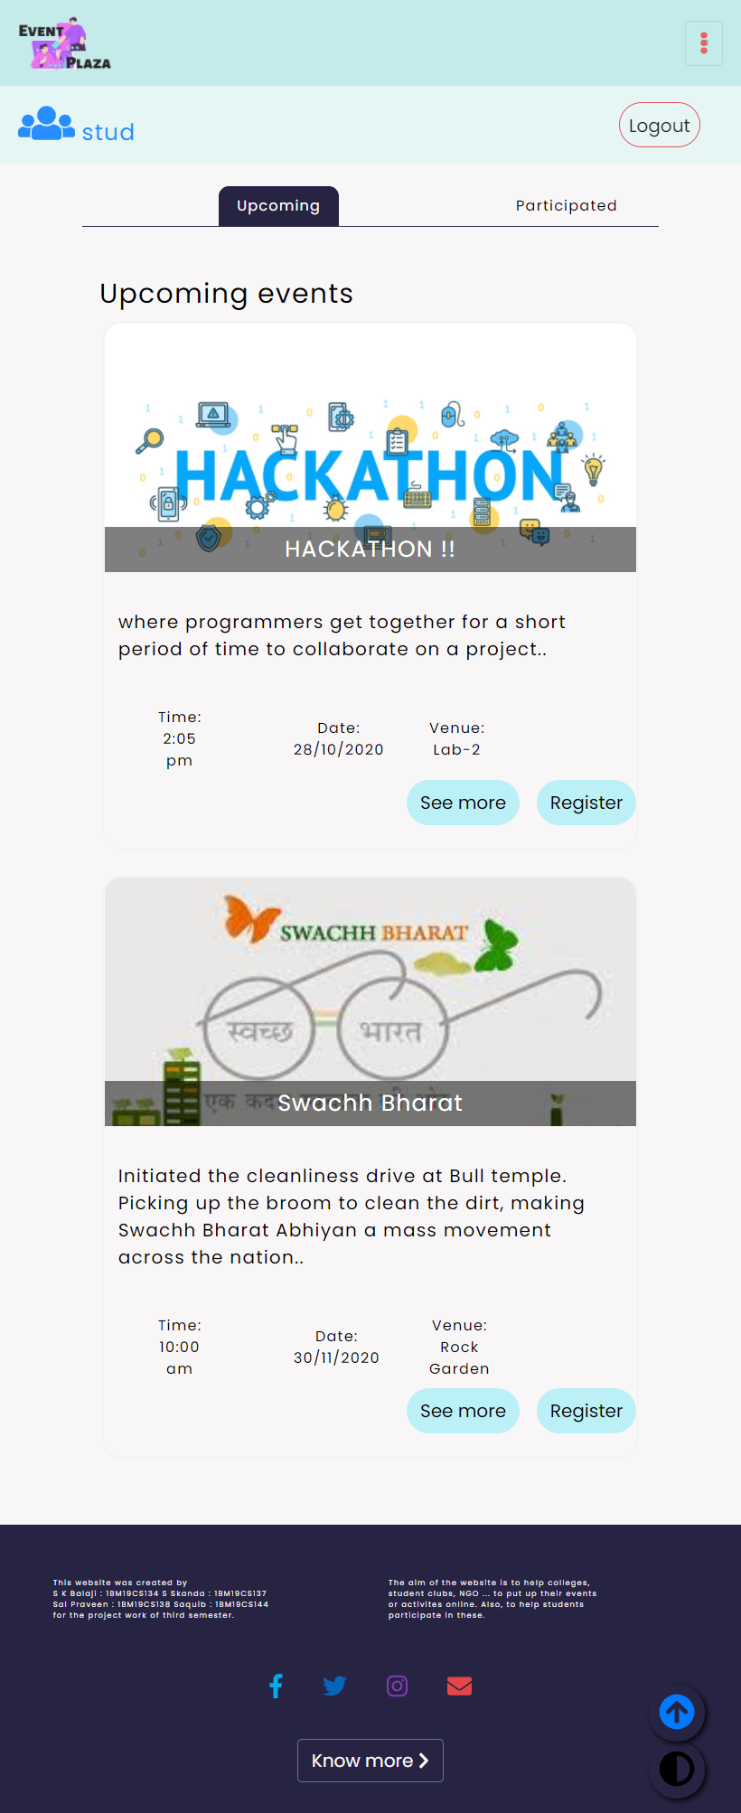

**REFERENCES**

1. *Images- https://unsplash.com/*
2. *Icons- https://fontawesome.com/*
3. *Bootstrap-* [*https://getbootstrap.com/*](https://getbootstrap.com/)
4. [*https://www.w3schools.com/*](https://www.w3schools.com/)
5. [*https://developer.mozilla.org/en-US/*](https://developer.mozilla.org/en-US/)

***Thank you***